Exercises

* Change the width and height of an image to 200 pixels both.
* Create an *OutlinedButton* widget that displays the text *Cancel*.
* Create a function called *cancel* that prints *Cancel button is clicked*, and pass it to the *onPressed* parameter of the *OutlinedButton* widget created in the previous step.
* Change the background color of the *OutlinedButton* widget to *Colors.purple*.
* Add a padding of 10 pixels to the *OutlinedButton* widget at the **top and bottom** only.
* Add a padding of 60 pixels to the *OutlinedButton* widget using *SizedBox* widget.

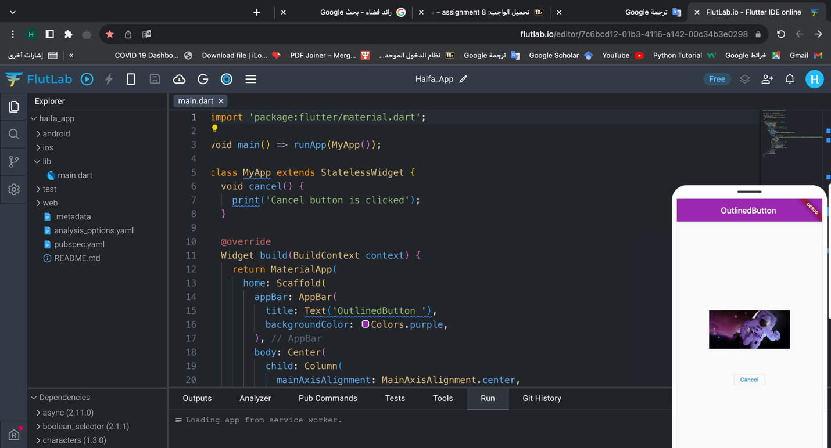

import 'package:flutter/material.dart';

void main() => runApp(MyApp());

class MyApp extends StatelessWidget {

void cancel() {

print('Cancel button is clicked');

}

@override

Widget build(BuildContext context) {

return MaterialApp(

home: Scaffold(

appBar: AppBar(

title: Text('OutlinedButton '),

backgroundColor: Colors.purple,

),

body: Center(

child: Column(

mainAxisAlignment: MainAxisAlignment.center,

children: [

Image(

image: NetworkImage(

"https://modo3.com/thumbs/fit630x300/274114/1648898282/%D9%85%D8%B9%D9%84%D9%88%D9%85%D8%A7%D8%AA_%D8%B9%D9%86_%D8%B1%D9%88%D8%A7%D8%AF_%D8%A7%D9%84%D9%81%D8%B6%D8%A7%D8%A1_%D9%84%D9%84%D8%A3%D8%B7%D9%81%D8%A7%D9%84.jpg"),

width: 200,

height: 200,

),

const SizedBox(height: 10),

OutlinedButton(

onPressed: cancel,

child: Text('Cancel'),

),

const SizedBox(height: 10),

],

),

),

),

);

}

}

